Derwent Primary School

Reading
Year 3
Term | Autumn 1 | Autumn 2 | Spring 1 | Spring 2 | Summer 1 | Summer 2
Text | Iron Man  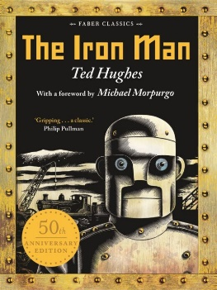 | Fantastic Mr Fox  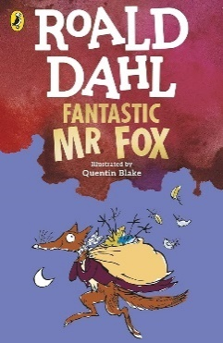 | Friend or Foe  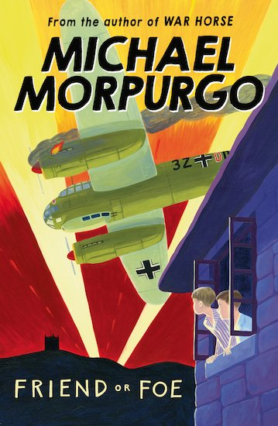 | Firework Maker’s Daughter  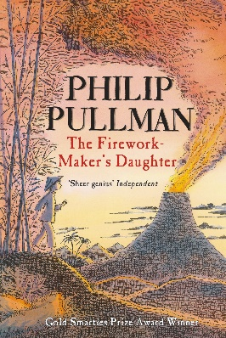 | Llama out Loud  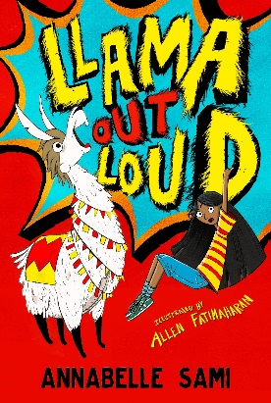

Year 4
Term | Autumn 1 | Autumn 2 | Spring 1 | Spring 2 | Summer 1 | Summer 2
Text | Roman Rescue  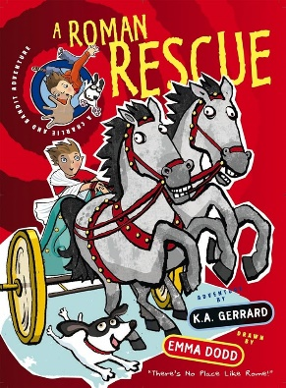 | Escape from Pompeii  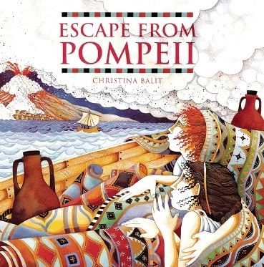 | Matilda  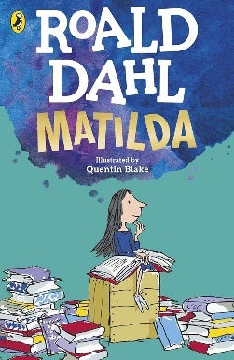 | Varjak Paw  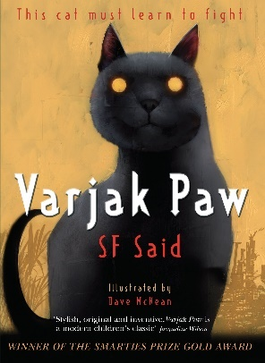 | The Lion, the Witch, and the Wardrobe  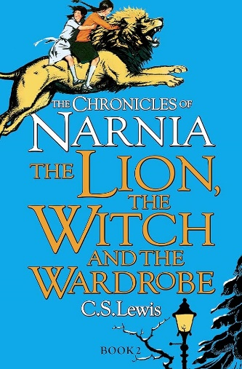

Year 5
Term | Autumn 1 | Autumn 2 | Spring 1 | Spring 2 | Summer 1 | Summer 2
Text | How to Train your Dragon  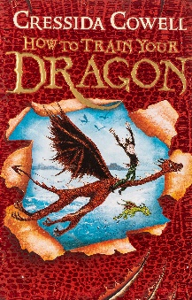 | Charlie and the Chocolate Factory  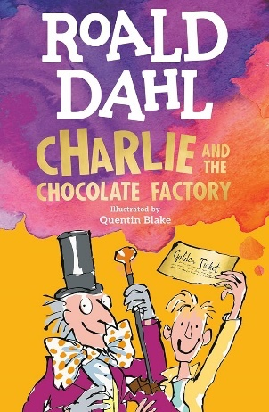 | Room 13  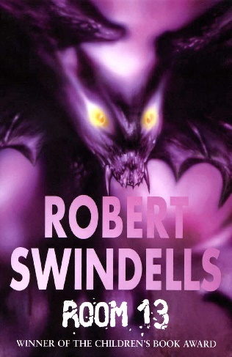 | Kensuke’s Kingdom  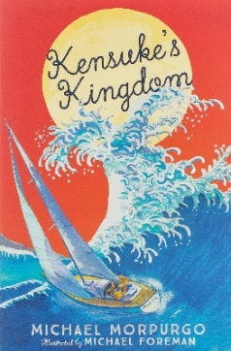 | Gruesome Grange  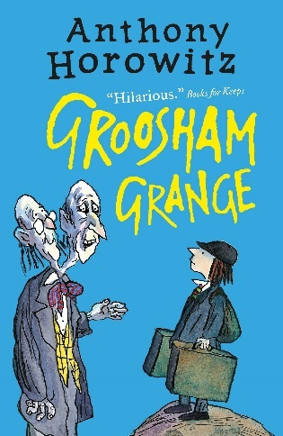

Year 6
Term | Autumn 1 | Autumn 2 | Spring 1 | Spring 2 | Summer 1 | Summer 2
Text | Street Child  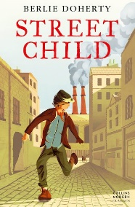 | Stig of the Dump  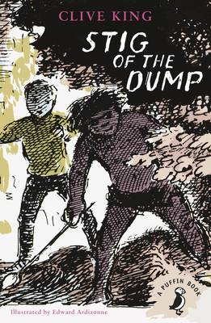 | Goodnight Mr Tom  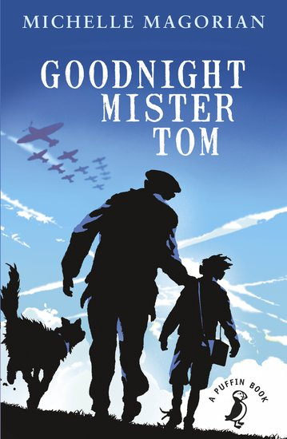

Year 2 – Shared Reading (finished RWI)

Term | Autumn 1 | Autumn 2 | Spring 1 | Spring 2 | Summer 1 | Summer 2
Fiction | Phonics | Phonics | The Giraffe, the Pelly, and Me  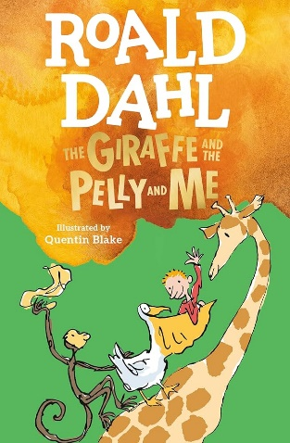 | The Owl who was afraid of the dark  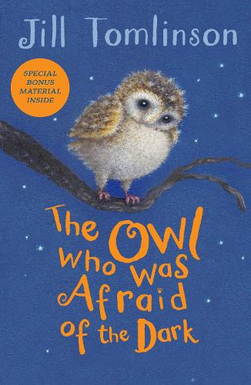 | The Dragon in the Library  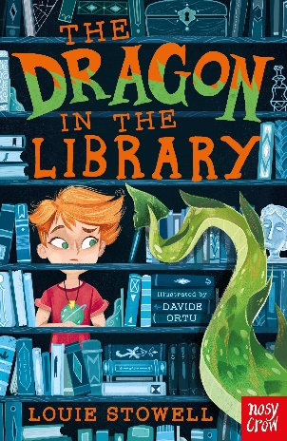 | 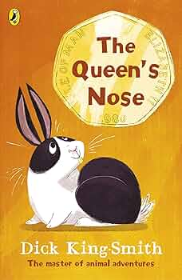  The Queen’s Nose

