Derwent Primary School

Reading

At our school, reading is at the heart of our curriculum. We believe that reading is the key that unlocks learning across every subject and opens doors to new worlds, ideas and opportunities. Our aim is for every child to develop a love of reading, to become confident, fluent readers, and to be able to understand and enjoy a wide range of texts.
We build strong foundations in early reading through high-quality phonics teaching, , ensuring that children quickly gain the skills they need to decode words and read with accuracy. As they progress, children are exposed to a rich and diverse reading spine of carefully chosen texts that challenge, inspire and reflect the wider world. These books are central to our curriculum, supporting vocabulary development, comprehension, empathy, and cultural awareness.
Reading is woven through every aspect of school life: from whole-class story time, to guided reading sessions, to opportunities for independent reading. We also work closely with families to promote reading for pleasure, celebrating books and stories as a community.
By the time children leave our school, we want them not only to read fluently and with understanding, but also to take with them a lifelong love of reading.

Year 3
Term | Autumn 1 | Autumn 2 | Spring 1 | Spring 2 | Summer 1 | Summer 2
Text | Iron Man  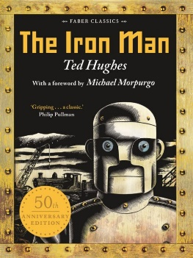 | Fantastic Mr Fox  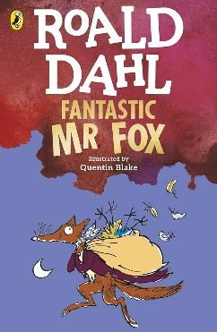 | Friend or Foe  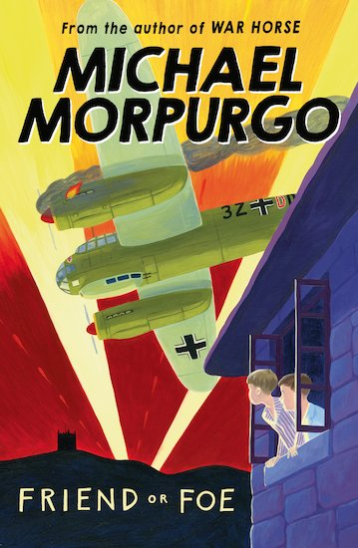 | Firework Maker’s Daughter  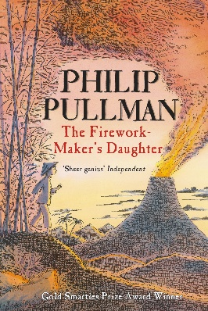 | Llama out Loud  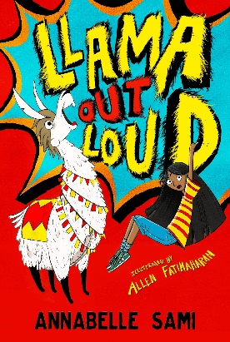

Year 4
Term | Autumn 1 | Autumn 2 | Spring 1 | Spring 2 | Summer 1 | Summer 2
Text | Roman Rescue  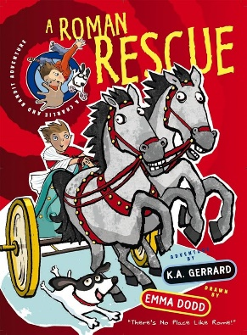 | Escape from Pompeii  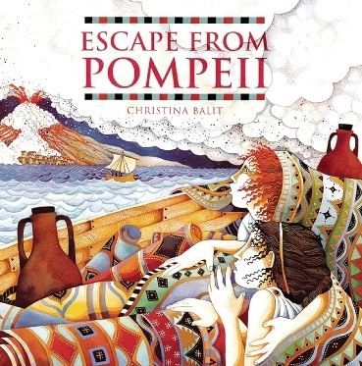 | Matilda  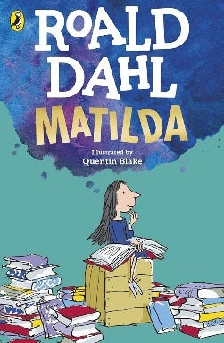 | Varjak Paw  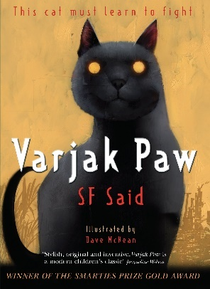 | The Lion, the Witch, and the Wardrobe  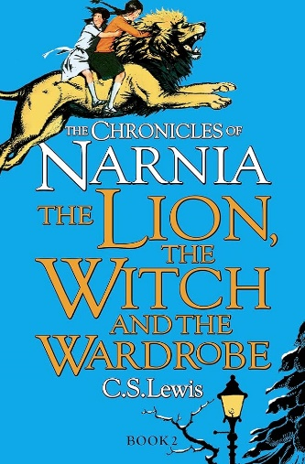

Year 5
Term | Autumn 1 | Autumn 2 | Spring 1 | Spring 2 | Summer 1 | Summer 2
Text | How to Train your Dragon  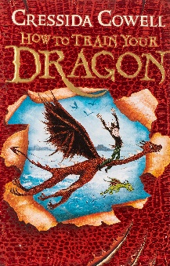 | Charlie and the Chocolate Factory  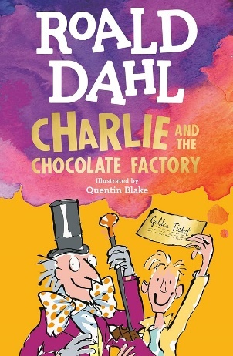 | Room 13  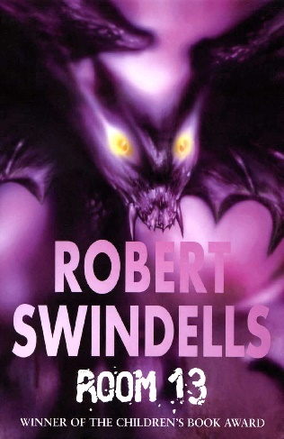 | Kensuke’s Kingdom  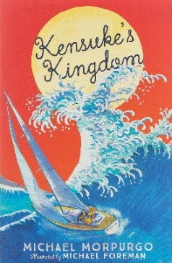 | Gruesome Grange  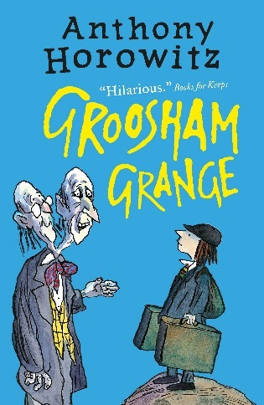

Year 6
Term | Autumn 1 | Autumn 2 | Spring 1 | Spring 2 | Summer 1 | Summer 2
Text | Street Child  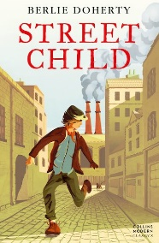 | Stig of the Dump  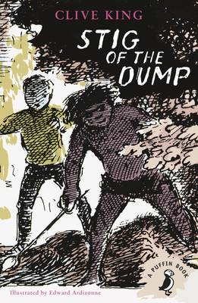 | Goodnight Mr Tom  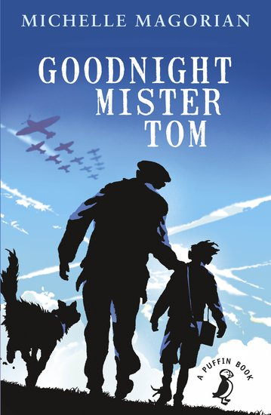

Year 2 – Shared Reading (finished RWI)

Term | Autumn 1 | Autumn 2 | Spring 1 | Spring 2 | Summer 1 | Summer 2
Fiction | Phonics | Phonics | The Giraffe, the Pelly, and Me  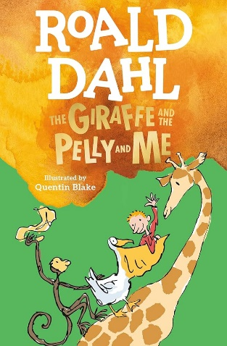 | The Owl who was afraid of the dark  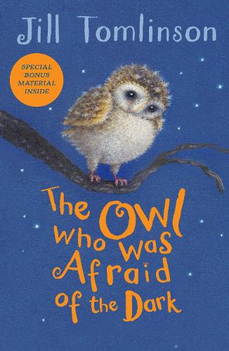 | The Dragon in the Library  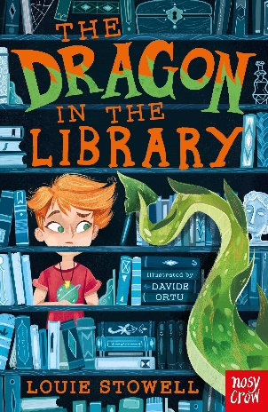 | 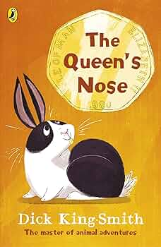  The Queen’s Nose

